Database Design for a Real-World Application
Application: FoodExpress – Online Food Delivery Platform

1. Name and Purpose of the Application
FoodExpress is an online food delivery platform that connects customers with restaurants. It allows customers to browse restaurant menus, place orders containing multiple items, track order status, get orders delivered by assigned delivery agents, and complete payment. The database must support these operations by storing customer, restaurant, menu, order, delivery, and payment information in a structured, relational way.

2. List of Required Tables
- Customers
- Restaurants
- MenuItems
- Orders
- OrderItems
- DeliveryAgents
- Payments
Seven tables in total. Each table maps to a distinct real-world entity or relationship in the ordering-and-delivery workflow; no table was added purely to inflate the count.

3. Columns / Attributes for Each Table

Customers
Column | Type | Notes
customer_id | INT | Primary key
name | VARCHAR(100)
phone | VARCHAR(15)
email | VARCHAR(100)
address | VARCHAR(255) | Delivery address

Restaurants
Column | Type | Notes
restaurant_id | INT | Primary key
name | VARCHAR(100)
cuisine_type | VARCHAR(50)
address | VARCHAR(255)
phone | VARCHAR(15)
rating | DECIMAL(2,1)

MenuItems
Column | Type | Notes
item_id | INT | Primary key
restaurant_id | INT | Foreign key -> Restaurants
item_name | VARCHAR(100)
price | DECIMAL(8,2)
category | VARCHAR(50) | e.g. starter, main, dessert
availability | BOOLEAN

Orders
Column | Type | Notes
order_id | INT | Primary key
customer_id | INT | Foreign key -> Customers
restaurant_id | INT | Foreign key -> Restaurants
agent_id | INT | Foreign key -> DeliveryAgents
order_date | DATETIME
status | VARCHAR(20) | placed / preparing / out for delivery / delivered / cancelled
total_amount | DECIMAL(10,2)

OrderItems
Column | Type | Notes
order_item_id | INT | Primary key
order_id | INT | Foreign key -> Orders
item_id | INT | Foreign key -> MenuItems
quantity | INT
subtotal | DECIMAL(8,2)

DeliveryAgents
Column | Type | Notes
agent_id | INT | Primary key
name | VARCHAR(100)
phone | VARCHAR(15)
vehicle_number | VARCHAR(20)
availability_status | BOOLEAN

Payments
Column | Type | Notes
payment_id | INT | Primary key
order_id | INT | Foreign key -> Orders
amount | DECIMAL(10,2)
payment_mode | VARCHAR(20) | UPI / card / cash on delivery
payment_status | VARCHAR(20) | pending / completed / failed
payment_date | DATETIME

4. Relationships Between the Tables
- Customers -> Orders: One-to-Many (one customer places many orders)
- Restaurants -> MenuItems: One-to-Many (one restaurant offers many menu items)
- Restaurants -> Orders: One-to-Many (one restaurant fulfills many orders)
- DeliveryAgents -> Orders: One-to-Many (one agent delivers many orders; each order has one agent)
- Orders <-> MenuItems: Many-to-Many, resolved through OrderItems (an order can contain many items; a menu item can appear in many orders)
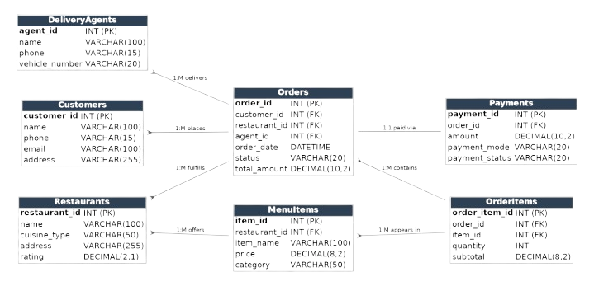
- Orders -> Payments: One-to-One (each order has exactly one payment record)

5. Purpose of Each Table
- Customers - stores user account and contact details needed to place and deliver orders.
- Restaurants - stores the partner restaurants available on the platform.
- MenuItems - stores the dishes each restaurant offers, with price and availability, so customers can browse and order.
- Orders - the central transaction record linking a customer, restaurant, and delivery agent, and tracking order status and total.
- OrderItems - junction table resolving the many-to-many relationship between orders and menu items, since one order usually contains multiple dishes.
- DeliveryAgents - stores delivery personnel details and assigns them to orders for fulfillment tracking.
- Payments - records how and whether each order was paid for, kept separate from the order so payment status can change independently.

